

Faculty of Computer and Informatics Engineering

Online Job Portal

Supervision Dr.Eng Fady Ibrahim

Students Work
Omar Nizam AlDeen Yaseen Dergham Maxeem Deeb

ABSTRACT
The aim of this project is to develops an online search Portal for the Placement Dept. of the college. The system is an online application that can be accessed throughout the organization and outside as well with proper login provided. This system can be used as an Online Job Portal for the Placement Dept of the college to manage the student information with regards to placement. Students logging should be able to upload their information in the form of a CV. Visitors/Company representatives logging in may also access/search any information put up by Students.
The project has been planned to be having the view of distributed architecture, with centralized storage of the database. The application for the storage of the data has been planned. Using the constructs of MS-SQL Server and all the user interfaces have been designed using the ASP.Net technologies. The database connectivity is planned using the “SQL Connection” methodology. The standards of security and data protective mechanism have been given a big choice for proper usage. The application takes care of different modules and their associated reports, which are produced as per the applicable strategies and standards that are put forwarded by the administrative staff.

INTRODUCTION
CONTENTS

  - INTRODUCTION TO PROJECT
  - PURPOSE OF THE PROJECT

SYSTEM ANALYSIS

  - SYSTEM WORKFLOW
  - STUDY OF THE SYSTEM

SYSTEM DESIGN

  - INTRODUCTION
  - DATA FLOW DIAGRAMS
  - DATA DICTIONARY

OUTPUT SCREENS

- CONCLUSION

- FUTURE IMPROVEMENT

- References

Chapter 1 INTRODUCTION

  - INTRODUCTION TO PROJECT
This project is aimed at developing an online search Portal for the Placement Details for job seekers. The system is an online application that can be accessed throughout the organization and outside as well with proper login provided. This system can be used as an Online Job Portal for job seekers. Job Seekers logging should be able to upload their information in the form of a CV. Visitors/Company representatives logging in may also access/search any information put up by Job aspirants.
.

PURPOSE OF THE PROJECT

This system can be used as an Online Job Portal for the Placements providing to the un employees who are seeking for a job placement. Job Seeker logging into the system and he can should be able to upload their information in the form of a CV. Visitors/Company representatives logging in may also access/search any information put up by Job Seeker.

Chapter 2

SYSTEM ANALYSIS

ANALYSIS MODEL
The model that is basically being followed is the WATER FALL MODEL, which states that the phases are organized in a linear order. First of all the feasibility study is done. Once that part is over the requirement analysis and project planning begins. If system exists one and modification and addition of new module is needed, analysis of present system can be used as basic model.
The design starts after the requirement analysis is complete and the coding begins after the design is complete. Once the programming is completed, the testing is done. In this model the sequence of activities performed in a software development project are: -
    - Requirement Analysis
    - Project Planning
    - System design
    - Detail design
    - Coding
    - Unit testing
    - System integration & testing

Here the linear ordering of these activities is critical. End of the phase and the output of one phase is the input of other phase. The output of each phase is to be consistent with the overall requirement of the system. Some of the qualities of


Requirements Engineering
Design
Programming
Maintenance
Process
Integration
Product
Product
Delivery
Input Output
Delivered Software Product
Integrated Software Product
Executable Software Modules
Design Specification
Requirements Specification
Communicated Requirements
Changed Requirements

Fig: Water Fall Model

  - STUDY OF THE SYSTEM
GUI’S

In the flexibility of the uses the interface has been developed a graphics concept in mind, associated through a browses interface. The GUI’S at the top level have been categorized as
- Administrative user interface

- The operational or generic user interface

The administrative user interface concentrates on the consistent information that is practically, part of the organizational activities and which needs proper authentication for the data collection. The interfaces help the administrations with all the transactional states like Data insertion, Data deletion and Date updation along with the extensive data search capabilities.
The operational or generic user interface helps the users upon the system in transactions through the existing data and required services. The operational user interface also helps the ordinary users in managing their own information helps the ordinary users in managing their own information in a customized manner as per the assisted flexibilities.
NUMBER OF MODULES

The system after careful analysis has been identified to be presented with the following modules:

The modules involved are:
    - Admin
    - Job Seeker
    - Job Provider
    - Notification
    - Search
    - Report
    - Authentication

Admin

In this module Admin will add all the qualifications, skill, experience, city, state, country and update and delete information about the job provider or job seeker he can also search for the job seeker and he can send mail to offer the job to job seeker and he can also see the jobs add by the job provider.

Job Seeker

In this module Job Seeker register him self and upload his resume and fill the profile give by admin and after login he will search for the job on various conditions and he can change his profiles and resume and he can apply for the jobs based on various conditions. He can see the response of the company and he can call the company person for the interview.

Job provider

In this module Job Provider register him self and his company and after login he will add new job and he can search for the job seekers on various condition and he can offer the job to job seeker according to the job profile and he can also see the response from the job seekers and send the mail.

Notification

In this module admin and job provider send the notification to the job seeker in the form of email.

Reports:-
This module contains all the information about the reports generated by the admin based on the particular job seeker, particular job provider, all job seeker and job provider, all jobs generated by the job providers.

Authentication:-
This module contains all the information about the authenticated user. User without his username and password can’t enter into the login if he is only the authenticated user then he can enter to his login.

PROJECT INSTRUCTIONS:

- Based on the given requirements, conceptualize the Solution Architecture. Choose the domain of your interest otherwise develop the application for ultimatedotnet.com. Depict the various architectural components, show interactions and connectedness and show internal and external elements. Design the web services, web methods and database infrastructure needed both and client and server.

- Provide an environment for upgradation of application for newer versions that are available in the same domain as web service target.

Chapter 3 SYSTEM DESIGN

INTRODUCTION
Software design sits at the technical kernel of the software engineering process and is applied regardless of the development paradigm and area of application. Design is the first step in the development phase for any engineered product or system. The designer’s goal is to produce a model or representation of an entity that will later be built. Beginning, once system requirement have been specified and analyzed, system design is the first of the three technical activities - design, code and test that is required to build and verify software.

The importance can be stated with a single word “Quality”. Design is the place where quality is fostered in software development. Design provides us with representations of software that can assess for quality. Design is the only way that we can accurately translate a customer’s view into a finished software product or system. Software design serves as a foundation for all the software engineering steps that follow. Without a strong design we risk building an unstable system – one that will be difficult to test, one whose quality cannot be assessed until the last stage.

During design, progressive refinement of data structure, program structure, and procedural details are developed reviewed and documented. System design can be viewed from either technical or project management perspective. From the technical point of view, design is comprised of four activities – architectural design, data structure design, interface design and procedural design.

DATA FLOW DIAGRAMS

A data flow diagram is graphical tool used to describe and analyze movement of data through a system. These are the central tool and the basis from which the other components are developed. The transformation of data from input to output, through processed, may be described logically and independently of physical components associated with the system. These are known as the logical data flow diagrams. The physical data flow diagrams show the actual implements and movement of data between people, departments and workstations. A full description of a system actually consists of a set of data flow diagrams. Using two familiar notations Yourdon, Gane and Sarson notation develops the data flow diagrams. Each component in a DFD is labeled with a descriptive name. Process is further identified with a number that will be used for identification purpose. The development of DFD’S is done in several levels. Each process in lower level diagrams can be broken down into a more detailed DFD in the next level. The lop-level diagram is often called context diagram. It consists a single process bit, which plays vital role in studying the current system. The process in the context level diagram is exploded into other process at the first level DFD.
The idea behind the explosion of a process into more process is that understanding at one level of detail is exploded into greater detail at the next level. This is done until further explosion is necessary and an adequate amount of detail is described for analyst to understand the process.
Larry Constantine first developed the DFD as a way of expressing system requirements in a graphical from, this lead to the modular design.
A DFD is also known as a “bubble Chart” has the purpose of clarifying system requirements and identifying major transformations that will become programs in system design. So it is the starting point of the design to the lowest level of detail. A DFD consists of a series of bubbles joined by data flows in the system.

DFD SYMBOLS:
In the DFD, there are four symbols
- A square defines a source(originator) or destination of system data
- An arrow identifies data flow. It is the pipeline through which the information flows
- A circle or a bubble represents a process that transforms incoming data flow into outgoing data flows.
- An open rectangle is a data store, data at rest or a temporary repository of data

Process that transforms data flow.

Source or Destination of data Data flow
Data Store

Fig 1

1st Level DFD’s

DFD For New Job Seeker Creation

Job Seeker Details
Registratio
Insert New Job Seeker
Verify Data
Check for Registration Details
Verify Data
Insert
Job Seeker

Fig 2

DFD For New Job Seeker Creation

Job Provider
Details
Registratio
Insert New Job Provider
Verify Data
Check for Registration Details
Verify Data
Insert
Job Provider

Fig 3

DFD For New Job Search Creation

Job Seeker Details
Registration Details
Search Job
Insert New Job Seeker
Check for Registration
Check For Job
Verify Data
Verify Data
Verify Data
Insert
Job Seeker Details

Fig 4

2nd Level DFD’s

DFD For New Recruitment Creation

Job Seeker Details
Designation Type Details
Job Provider Details
Insert New Job Seeker
Check for Designation
Verify Data
Verify Data
Verify Data
Check for Job Provider
Check for Job Seeker Info
Check for Type
Check for Status
Verify Verify Verify Data
Data Data
Job Seeker Details
Job Provider Status Details
Job Seeker Details
Inser
Fig 5
Job Seeker Details

3rd Level DFD’S

DFD For New Recruitment Creation
Request for new Job Seeker
Generate Emp-Id ()
Validate Desg-Id ()
Validate
Prod-Id ()

Commit ()
Validate Prod-Status-
ID ()
Validate Job- Seek-Id ()

Database Updated
Job Seeker Details
Job Seeker status Details
Job Provider Status Details
Designation Type Details
Job Seeker Details
Job Provider Details

Fig 6

Collaboration Diagrams
Admin Login
Admin Add Collaboration Diagram

DataBase
4 : ExecuteNonQuery()
3 : ExecuteNonQuery()
5 : Response To ExecuteNonQuery()
BAL : clsCountry
DAL : sqlhelper

Fig 7
2 : InsertCountry()

6 : Return Response()
ow Result()
1 : Add Country()
Country
7 : Sh
Admin

Admin Add City Collaboration Diagram

DataBase
4 : ExecuteNonQuery()
3 : ExecuteNonQuery()
5 : Response To ExecuteNonQuery()
BAL : clsState
DAL : sqlhelper

2 : InsertCity()
6 : Return Response()

ow Result()
7 : Sh

1 : Add City()
City

Admin

Fig 8

Registration Collaboration Diagram

DataBase
3 : ExecuteNonQuery()
2 : ExecuteNonQuery()
4 : Response to ExecuteNonQuery()
DAL : SqlHelper

Fig 9
1 : Registration()
ow Result()
5 : Return Response()
Registration
6 : Sh
BAL : ClsRegistration

JobRecuriter Update Profile

5 : Response To ExecuteNonQuery()
DataBase
BAL : clsJobrecuriterProfile

4 : ExecuteNonQuery()
3 : ExecuteNonQuery()

2 : UpdateProfile()
6 : Return Response()
DAL : sqlhelper

ow Result()
7 : Sh

1 : ModifyProfile()
Update JobRecuriter Profile
JobRecuriter

Fig 10

City

DataBase | 5 : Execute_Nonquery() | Dal : sqlhelper

Fig 11
4 : InsertCities()
6 : return response()
3 : btn_Add()
lid Data()
1 : lnkCity()
frmCity
2 : Inva
Admin
Bal : clsCity

Country

5 : Execute_Nonquery()
4 : InsertCountries()
6 : return response()
3 : btn_Add()
alid Data()
1 : lnkCountry()
frmCountry
2 : Inv
Admin
Bal : clsCountry
Dal : sqlhelper
DataBase

Fig 12

User Registration

5 : Execute_Nonquery()
Dal : sqlhelper
DataBase

4 : InsertUserDetails()

6 : return response()

Bal : clsUser
3 : btn_submit()

alid Data()
2 : Inv

1 : lnkUser()
frmUser

Home

Fig 13

Sequence Diagrams:

SEQUENCE DIAGRAMS
Sequence Diagrams Represent the objects participating the interaction horizontally and time vertically.
Admin Login


1 : Login()
2 : CheckUser()
3 : Execute NonQuery()
4 : Exeute NonQuery()
5 : Response to ExecuteNonQuery()
6 : Get Response()

7 : Show Result()
Login
Admin
Dal : SqlHelper
Bal : AdminLogin
DataBase

Fig 14

Admin Add Country Sequence Diagram


1 : Add Country()
2 : InsertCountry()
3 : ExecuteNonQuery()
4 : ExecuteNonQuery()
5 : Response To ExecuteNonQuery()
6 : Return Response()

7 : Show Result()
DAL : sqlhelper
BAL : clsCountry
Country
Admin
DataBase

Fig 15

Admin Add State Sequence Diagram

1 : Add State()
2 : InsertState()
3 : ExecuteNonQuery()
4 : ExecuteNonQuery()
5 : Response To ExecuteNonQuery()
6 : Return Response()

7 : Show Result()
DAL : sqlhelper
BAL : clsState
State
Admin
DataBase

Fig 16

Admin Add City Sequence Diagram


1 : Add City()
2 : InsertCity()
3 : ExecuteNonQuery()
4 : ExecuteNonQuery()
5 : Response To ExecuteNonQuery()
6 : Return Response()

7 : Show Result()
DAL : sqlhelper
BAL : clsState
City
Admin
DataBase

Fig 17

Jobseeker Update Profile Sequence Diagram


1 : ModifyProfile()
2 : UpdateProfile()
3 : ExecuteNonQuery()
4 : ExecuteNonQuery()
5 : Response To ExecuteNonQuery()
6 : Return Response()

7 : Show Result()
DAL : sqlhelper
BAL : clsUpdateJobSeekerProfile
Update Jobseeker Profile
JobSeeker
DataBase

Fig 18
JobRecuriter Update Profile Sequence Diagram


1 : ModifyProfile()
2 : UpdateProfile()
3 : ExecuteNonQuery()
4 : ExecuteNonQuery()
5 : Response To ExecuteNonQuery()
6 : Return Response()

7 : Show Result()
DAL : sqlhelper
BAL : clsJobrecuriterProfile
Update JobRecuriter Profile
JobRecuriter
DataBase

Fig 19

Registration Sequence Diagram


r
1 : Registration()
2 : ExecuteNonQuery()
3 : ExecuteNonQuery()
4 : Response to ExecuteNonQuery()
5 : Return Response()
ow Result()
6 : Sh
DataBase
Registration
BAL : ClsRegistration
DAL : SqlHelpe

Fig 20

  - DATA DICTONARY
After carefully understanding the requirements of the client the the entire data storage requirements are divided into tables. The below tables are normalized to avoid any anomalies during the course of data entry.

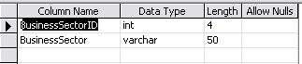
City Details
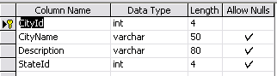
Country Details
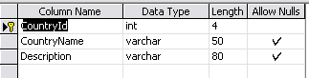
Experience Detail
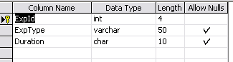
Functional Area
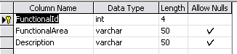
Job Openinng Detail

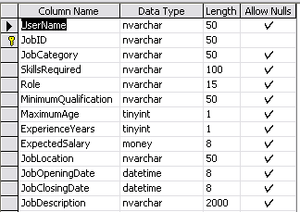
Jobseeker Response to Recruiter
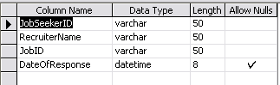
Job Type Detail
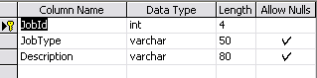
Location Master
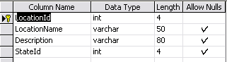
Qualification
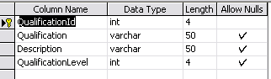
Recruiter Account Details
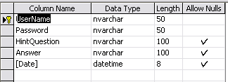
Recruiter Organization Details

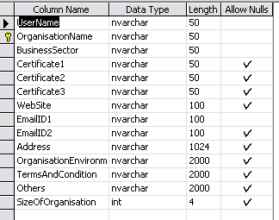
Recruiter Response to Jobseeker
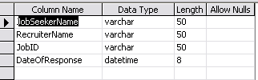
Skill Master
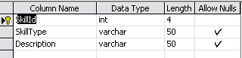
State detail
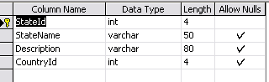
Student Detail
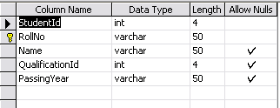
Admin Login
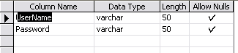
Jobseeker Background Details

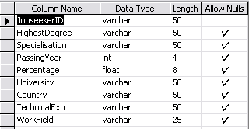
Contact Details
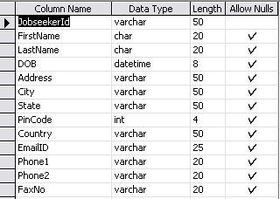
Jobseeker Job Details
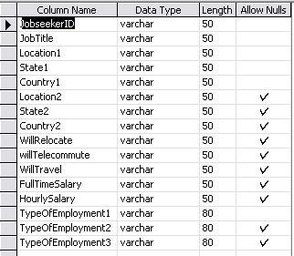

Jobseeker Registration

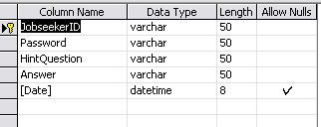
Jobseeker Resume
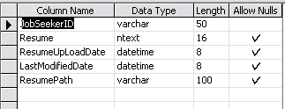
Jobseeker Technical Details
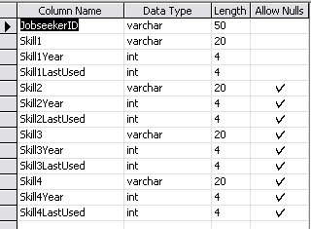

Chapter 4 OUTPUT SCREENS

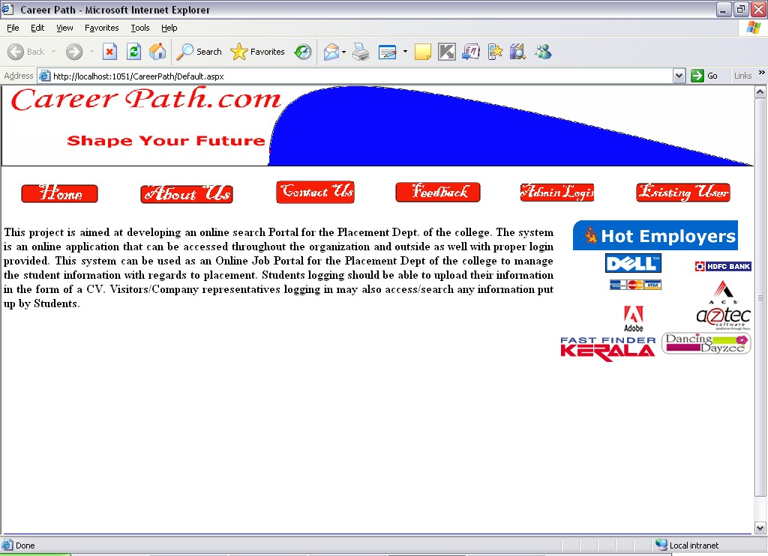

Fig 21

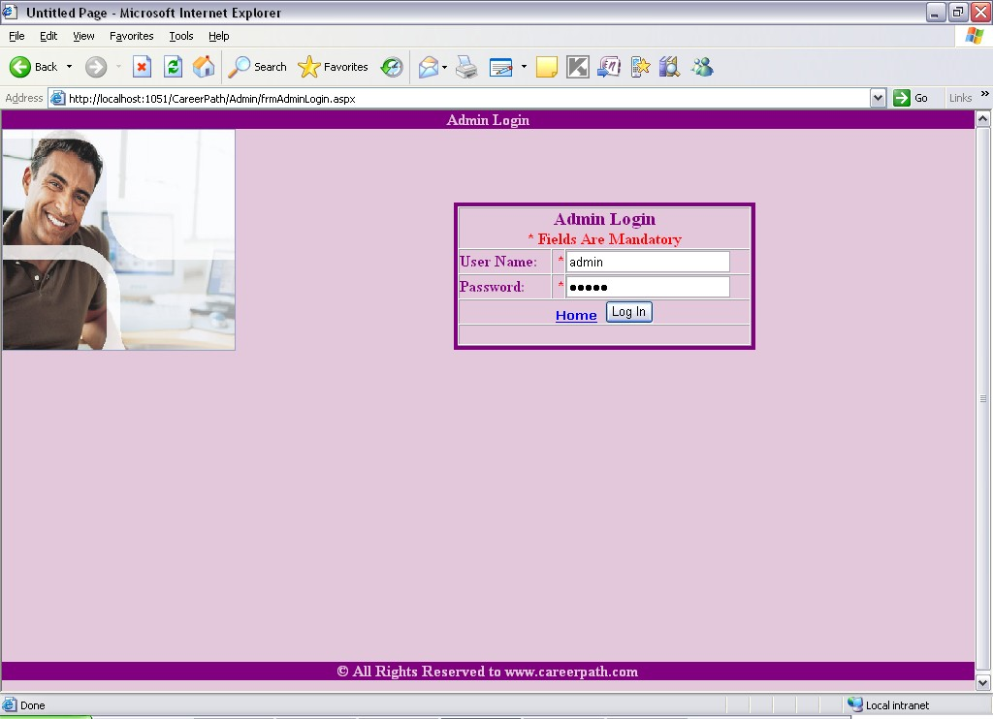

Fig 22

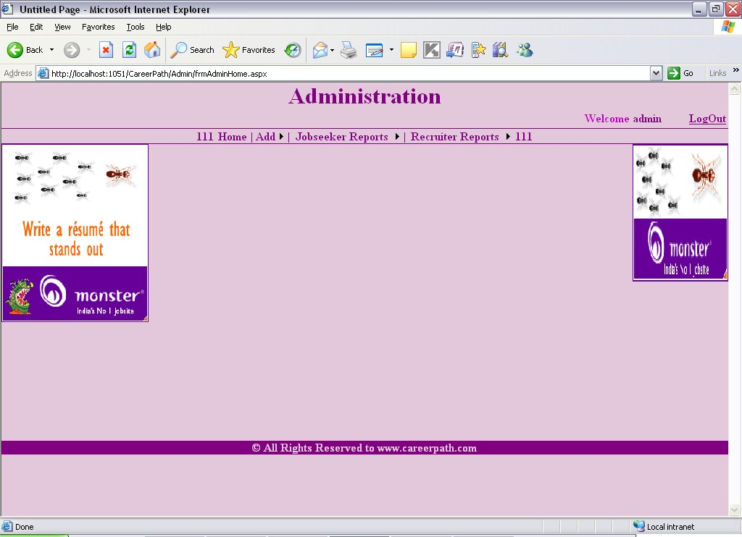

Fig 23

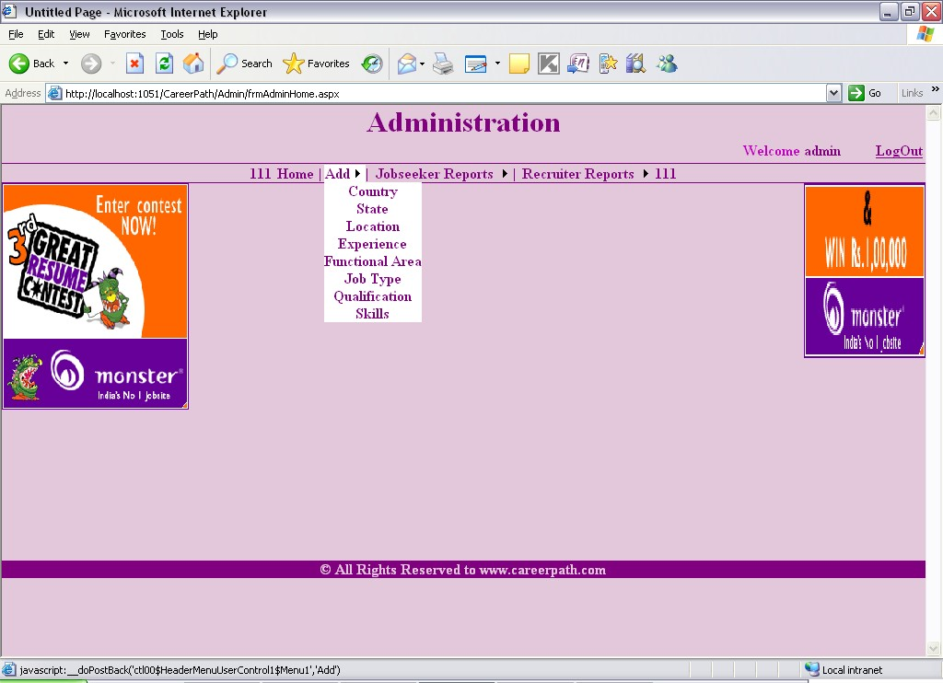

Fig 24

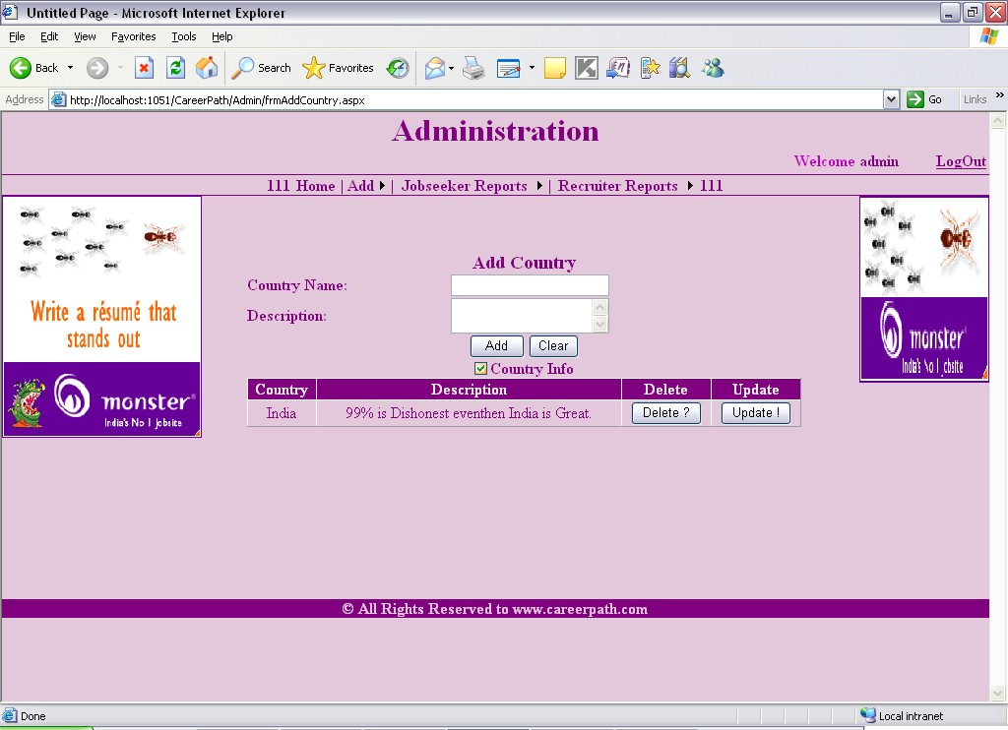

Fig 25

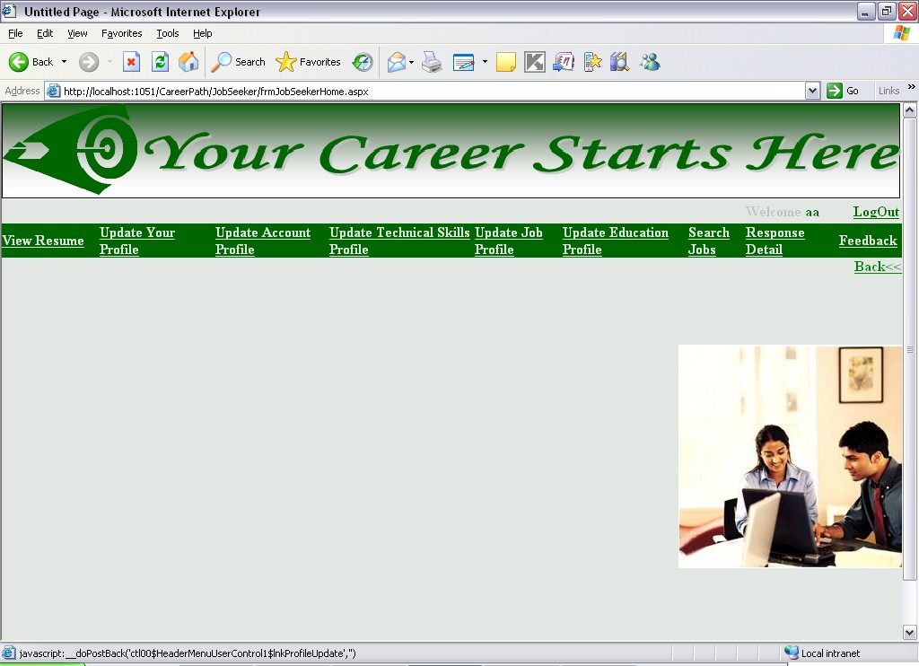

Fig 26

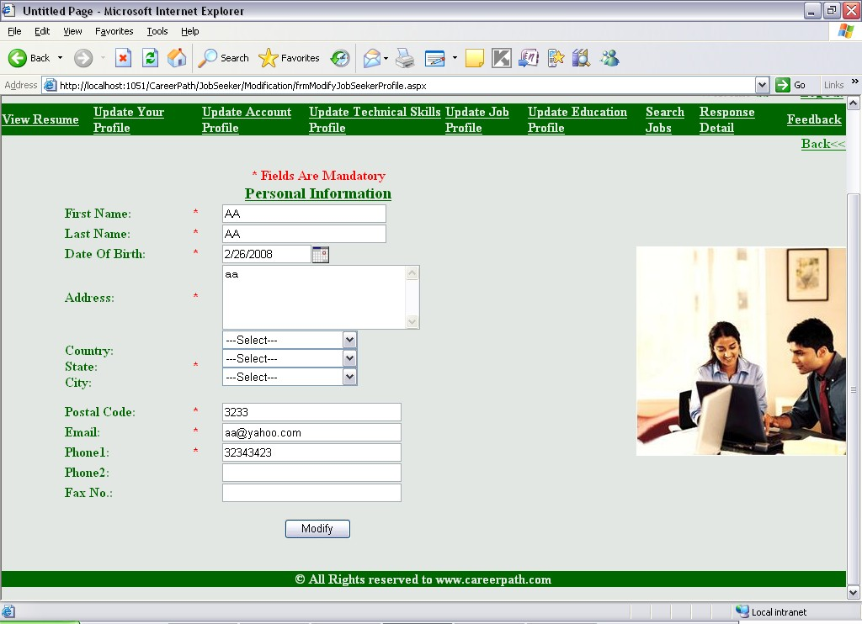

Fig 27

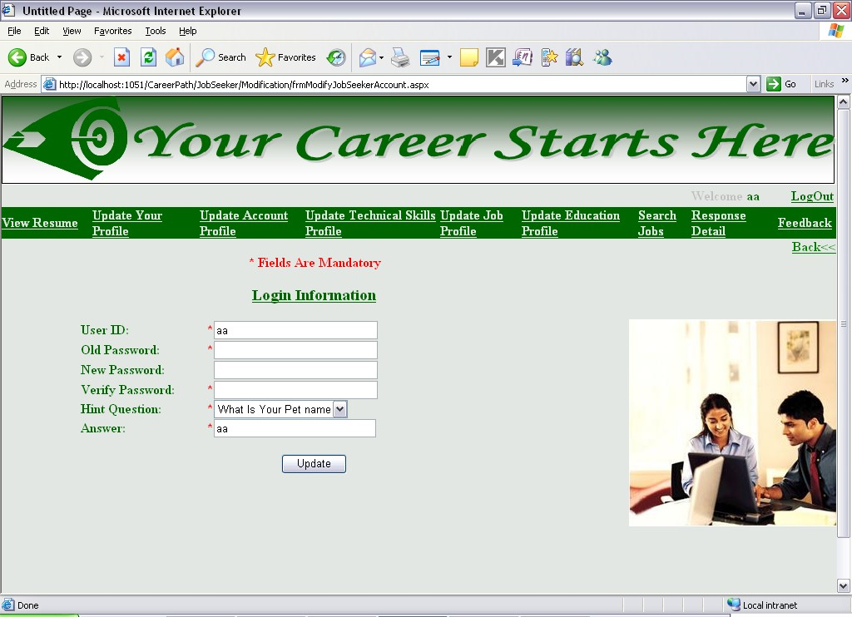

Fig 28

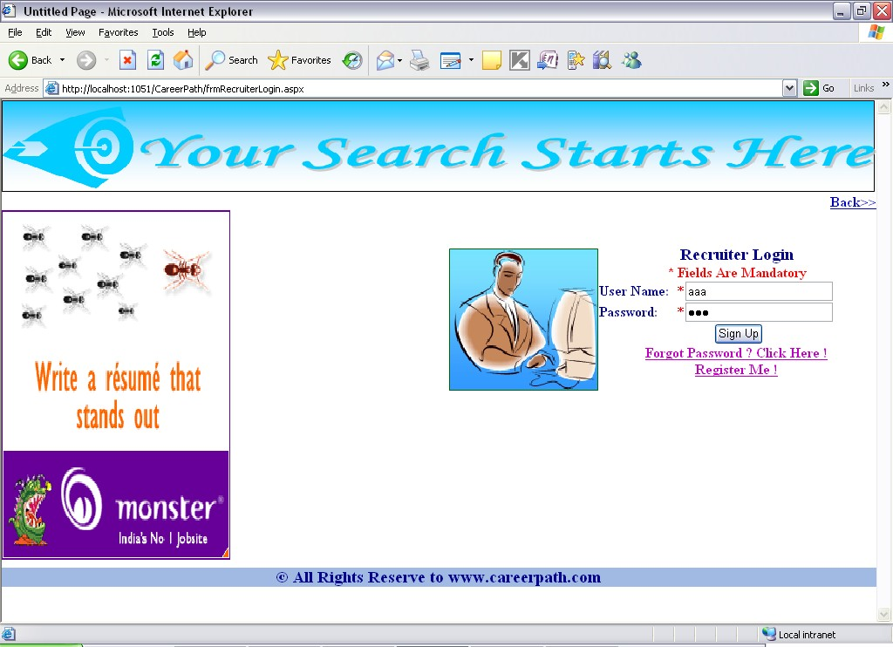
Fig 29

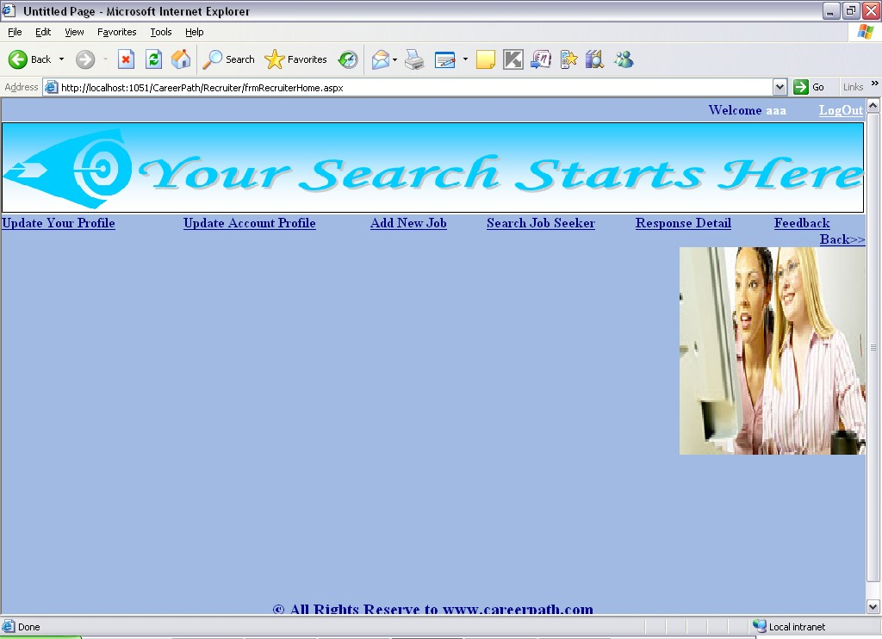

Fig 30

Chapter 5

CONCLUSION

It has been a great pleasure for me to work on this exciting and challenging project. This project proved good for me as it provided practical knowledge of not only programming in ASP.NET and VB.NET web based application and no some extent Windows Application and SQL Server, but also about all handling procedure related with “PROJECT NAME”. It also provides knowledge about the latest technology used in developing web enabled application and client server technology that will be great demand in future. This will provide better opportunities and guidance in future in developing projects independently.

BENEFITS:

The project is identified by the merits of the system offered to the user. The merits of this project are as follows: -
- It’s a web-enabled project.
- This project offers user to enter the data through simple and interactive forms. This is very helpful for the client to enter the desired information through so much simplicity.
- The user is mainly more concerned about the validity of the data, whatever he is entering. There are checks on every stages of any new creation, data entry or updation so that the user cannot enter the invalid data, which can create problems at later date.
- Sometimes the user finds in the later stages of using project that he needs to update some of the information that he entered earlier. There are options for him by which he can update the records. Moreover there is restriction for his

that he cannot change the primary data field. This keeps the validity of the data to longer extent.
- User is provided the option of monitoring the records he entered earlier. He can see the desired records with the variety of options provided by him.
- From every part of the project the user is provided with the links through framing so that he can go from one option of the project to other as per the requirement. This is bound to be simple and very friendly as per the user is concerned. That is, we can sat that the project is user friendly which is one of the primary concerns of any good project.
- Data storage and retrieval will become faster and easier to maintain because data is stored in a systematic manner and in a single database.
- Decision making process would be greatly enhanced because of faster processing of information since data collection from information available on computer takes much less time then manual system.
- Allocating of sample results becomes much faster because at a time the user can see the records of last years.
- Easier and faster data transfer through latest technology associated with the computer and communication.
- Through these features it will increase the efficiency, accuracy and transparency,

LIMITATIONS:

- The size of the database increases day-by-day, increasing the load on the database back up and data maintenance activity.
- Training for simple computer operations is necessary for the users working on the system.

Chapter 6

FUTURE WORK

  - This System being web-based and an undertaking of Cyber Security Division, needs to be thoroughly tested to find out any security gaps.

  - A console for the data centre may be made available to allow the personnel to monitor on the sites which were cleared for hosting during a particular period.

  - Moreover, it is just a beginning; further the system may be utilized in various other types of auditing operation viz. Network auditing or similar process/workflow based applications...

Books
Chapter 7 References

Conallen, J. (2003). Building Web Applications with UML. Pearson Education, Inc.
  - Firth, R. (2005). High Powered CVs. How to Books Publishing.
  - Maier, M. & Rechtin, E. (2000). The Art of Systems Architecting 2nd Edition. CRC Press.
  - Schmuller, J. (2004). Sams Teach Yourself UML in 24 Hours, Third Edition. Sams Publishing.
Articles/Journals
  - Boyce, A. (2002). Online Job Hunting: A Pew Internet Project Data Memo. Pew Internet and
American Life Project. Published: July 17, 2002.
  - Dewar, J. (2008). Using an Employment Agency to Best Effect. Success @ Work. Published:
January 2008.
  - Dorn, J. & Naz, T. (2007). Meta-Search in Human Resource Management. International
Journal of Social Sciences.
  - Kuhn, P. & Skuterud, M. (2000). Job Search Methods:
Internet versus Traditional. Monthly Labor Review. Published: October 2000.
Web Sites
  - http://www.bestjobs.ph
  - http://www.gopinoy.com
  - http://www.jobsdb.com.ph
  - http://www.jobsonline.com.ph
  - http://www.jobstreet.com.ph
  - http://www.phil-job.net

